**Robotics**

**Exercise 4.1 Composition of poses and landmarks**

The purpose of this exercise is to get familiar with the process of observing landmarks from robot poses. The main tools for that are:

* the **composition of two poses** and the **composition of a pose and a landmark.**
* the **propagation of uncertainty** through the Jacobians of these compositions.

We will address several problems in an incremental complexity way. The following figures will help you to follow the exercise.

*r*

Sensor pose:

Landmark observation:



Landmark observation:

Robot/Sensor pose:



$$m$$

$$m_{2}$$

$$x$$

$$y$$

$$p_{1}$$

$$p_{2}$$

$$p_{12}$$

$$m_{1}$$

$$z_{1}$$

$$z_{2}$$

$$R_{1}$$

$$R_{2}$$

*x*

*y*



1. Let’s consider a robot R1 at a perfectly known pose p1 = [1, 2, 0.5]T which observes a landmark *m* with a range-bearing (polar) sensor affected by a zero-mean Gaussian error with covariance W1p = diag([0.25, 0.04]). The sensor provides the measurement z1p = [4m., 0.7rad.] T. Compute the Gaussian probability distribution (mean and covariance)of the landmark in the world frame (the same as the robot) and plot its corresponding ellipse (in magenta, sigma=1).

*Hint*: Prior to propagate the measurement uncertainty, we need to compute the covariance of the observation in the Cartesian robot R1 frame:



z1xc_r = r*c;

z1yc_r = r*s;

zc_r = [z1xc_r, z1yc_r];

J_pc = [c -r*s;

s r*c];

Wzc_r = J_pc*W1p_r*J_pc';

z1_w = tcomp(p1_w,[zc_r';1])

J_ap = [1 0 -axp*so-ayp*co;

0 1 axp*co-ayp*so];

J_aa = [co -so;

so co];

Wzc_w = J_ap*Qp1_w*J_ap' + J_aa*Wzc_r*J_aa'

PlotEllipse(z1_w(1:2),Wzc_w,1,'m');

DrawRobot(p1_w,'b');

1. Now, let’s assume that the robot pose is not known, but a RV that follows a Gaussian probability distribution: p1 ~ N([1, 2, 0.5]T, 1) with 1 = diag([0.08,0.6, 0.02]).
   1. Compute the covariance matrix m1 of the landmark in the world frame and plot it as an ellipse centered at the mean m1 (in blue, sigma= 1). Plot also the covariance of the robot pose (in blue, sigma= 1).

Wzc_w = J_ap*Qp1_w*J_ap' + J_aa*Wzc_r*J_aa'

PlotEllipse(p1_w(1:2),Qp1_w,1,'b');

PlotEllipse(z1_w(1:2),Wzc_w,1,'b');

* 1. Compare the covariance with that obtained in the previous case. Is it bigger? Is it bigger than that of the robot? Why?

Yes, it is bigger than the initial and the robot. It is because of the error in the position of the robot which makes the error of the landmark bigger. So, the error landmarks are the combination of the error in the robot and the error of the sensor.

1. Another robot R2 is at pose p2 ~ ([6m., 4m., 2.1rad.]T, 2) with 2 = diag([0.20,0.09, 0.03]). Plot p2 and its ellipse (covariance) in green (sigma=1). Compute the relative pose p12 between R1 and R2. For that, take a look at the file *“Clarifying the relative pose between to poses”* and implement the two possible ways to obtain such pose.

PlotEllipse(p2_w(1:2),Qp2_w,1,'g');

DrawRobot(p2_w,'g');

% First way: composition of poses with inverse pose

p1inv_w = tinv(p1_w);

p12_w = tcomp(p1inv_w,p2_w)

JacInv = Jinv(p1_w);

Qinvp1_w = JacInv*Qp1_w*JacInv';

JacP12Inv=J1(p1inv_w,p2_w);

JacP12P2=J2(p1inv_w,0);

Qp12_w = JacP12Inv*Qinvp1_w*JacP12Inv'+JacP12P2*Qp2_w*JacP12P2'

% Second way: Inverse Composition

J_p12p1 =[-c -s -(xp2-xp1)*s+(yp2-yp1)*c

s -c -(xp2-xp1)*c-(yp2-yp1)*s

0 0 -1];

J_p12p2 = [c s 0;

-s c 0;

0 0 1];

Qp12_w = J_p12p1*Qp1_w*J_p12p1'+J_p12p2*Qp2_w*J_p12p2'

1. According to the information that we have about the position of the landmark *m* in the world coordinates (provided by R1), compute the predicted observation distribution of *z2p =*[*r*, *α*] ~ N([*z2p*, W2p) by a range-bearing sensor from R2.

*Hint*: We need to compute the covariance of the predicted observation in *Polar* coordinates (W2p). For that, use the following *Jacobian*:

$$\frac{∂p}{∂c}= \left[\begin{matrix}cos⁡(α+θ) & sin⁡(α+θ) \\ {-\sin\left(α+θ\right)}/r & {cos⁡(α+θ)}/r\end{matrix}\right]$$

r2 = sqrt(sum((z1_w(1:2)-p2_w(1:2)).^2));

xi=z1_w(1);yi=z1_w(2);

x=p2_w(1);y=p2_w(2);

alpha2 = atan2((yi-y),(xi-x))-p2_w(3);

z2p_r = [r2,alpha2]'

alpha = alpha2 + p2_w(3);

ca=cos(alpha); sa=sin(alpha);

Jcp_p2 = [ca sa;

-sa/r2 ca/r2];

W2_p = Jcp_p2*Wzc_w*Jcp_p2'

1. Assume now that a measurement z2 = [4m., 0.3rad.] T of the landmark is taken from R2 with a sensor having the same precision as that of R1 (W2p= W1p).
   1. What is the pdf of the observed landmark according to this observation? Plot the corresponding ellipse (in green, sigma=1).

x2 = r*c;

y2 = r*s;

z2c_r = [x2,y2];

J_pc = [c -r*s;

s r*c];

Wz2c_r = J_pc*W2p_r*J_pc';

J_ap = [1 0 -axp*so-ayp*co;

0 1 axp*co-ayp*so];

J_aa = [co -so;

so co];

Wz2c_w = J_ap*Qp2_w*J_ap' + J_aa*Wz2c_r*J_aa'

z2_w = tcomp(p2_w,[z2c_r';1])

plot(z2_w(1),z2_w(2),'xg');

PlotEllipse(z2_w(1:2),Wz2c_w,1,'g');

* 1. Two different pdf’s are now associated to the same landmark.
     1. Is that a contradiction?

It is not a contradiction because each sensor caught the landmark as well as they could, but these sensors have error in theirs measures.

* + 1. Can you work out a solution that combines these two “pieces of information”? Plot it (in red).

Since each probability is independent for each other, we can do:

$$p\left(z | x,m\right)= \prod_{k=1}^{K}{p(z_{k}|x,m)}$$

So, we must multiply the two gaussians probabilities.

Wz_w = inv(inv(Wzc_w)+inv(Wz2c_w))

z_w=Wz_w*(Wzc_w\z1_w(1:2)+Wz2c_w\z2_w(1:2))

plot(z_w(1),z_w(2),'xr');

PlotEllipse(z_w(1:2),Wz_w,1,'r');

**Results:**

**All the plots of the exercise:**

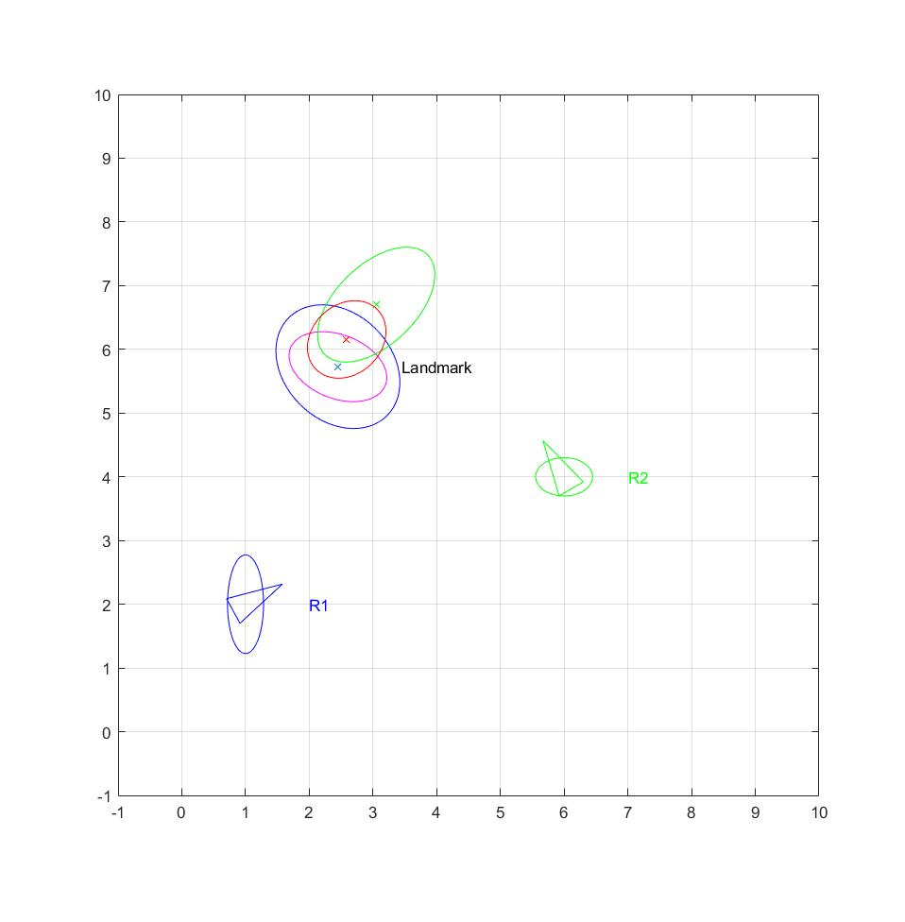

Image 1

The image shows the relative position of both robots and the landmark with the respective error, which are gaussian. The pink landmark error is caused by the blue robot sensor without a robot error, the blue one, by the blue robot sensor with a robot error, the green one, by the green robot sensor with a robot error and the red one is the combination caused by both sensors.

**4.1.1 Sensor measurement in the world's coordinate system (mean and covariance)**

z1_w = [2.4494, 5.7282, 1.5000]’

Wz1_w = [0.5888 -0.1317

-0.1317 0.3012]

**4.1.2 Sensor measurement in the world's coordinate system with uncertainty in the robot pose**

Wz1_w = [0.9468 -0.2398

-0.2398 0.9432]

**4.1.3 Relative pose (Gaussian distribution) between R1 and R2.**

p12_w = [5.3468, -0.6420, 1.6000]’

Qp12_w = [0.3825 0.2411 0.0128

0.2411 1.1675 0.1069

0.0128 0.1069 0.0500]

**4.1.4 Predicted observation of the landmark m by a range-bearing sensor from R2**

Z2p_r= [3.9488 m., 0.5886rad]

W2_p = [1.1348 -0.0371

-0.0371 0.0484]

**4.1.5 Sensor measurement from R2 in the world's coordinate system (mean and covariance)**

z2_w = [3.0504, 6.7019, 3.1000]’

Wz2c_w = [0.8469 0.4333

0.4333 0.8131]

**Combined information**

z_w = [2.5876, 6.1553]’

Wz_w = [0.3797 0.0777

0.0777 0.3700]